Neural Networks and Deep Learning Report

Preamble:

* Training data points 49
* Testing data points 15

**Part 1:**

**Results Part 1:**

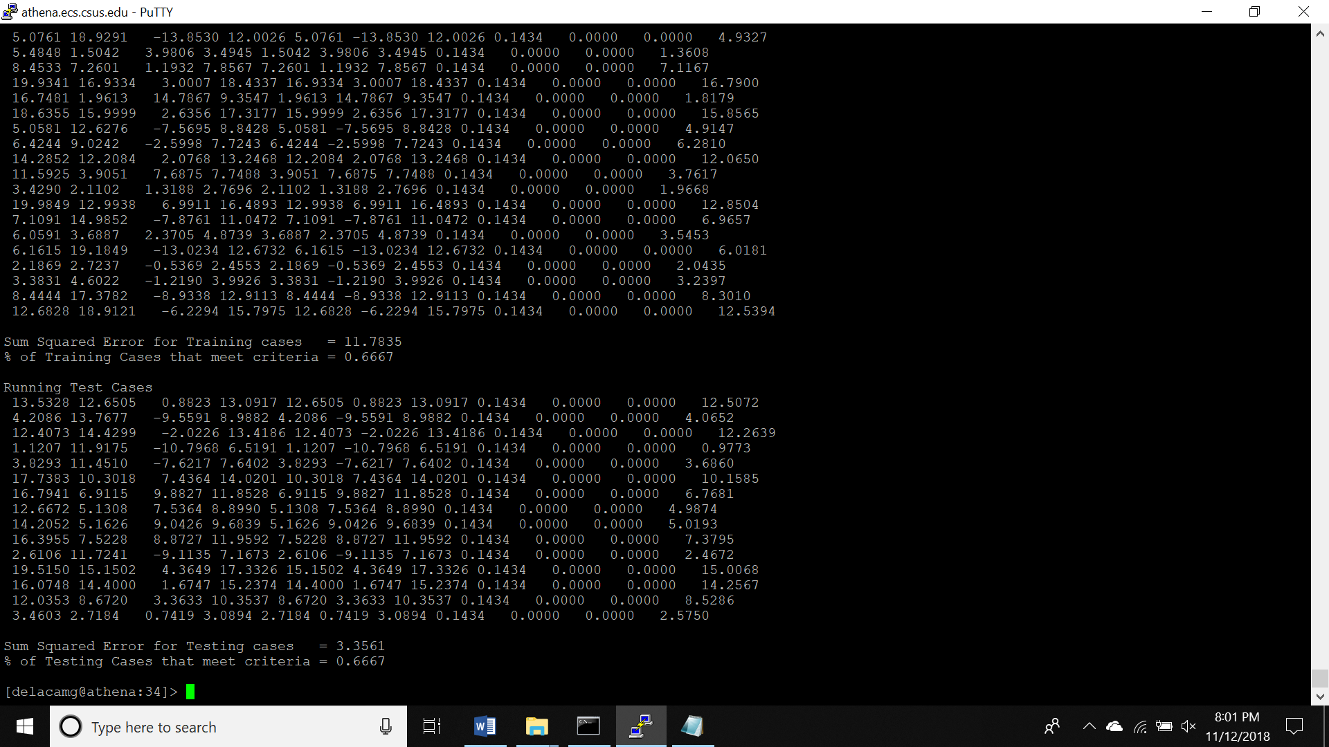

**Analysis Part 1:**

* The Neural Network was able to quickly learn the training set for the average and difference to a precision of 100%. However, it seems to have some trouble learning the minimum solution for the training set.
* The training took about 7.5 seconds to run 1000000 iterations, with a sum squared error for the training cases of 11.7835 and 66.7% cases meeting criteria.
* The Network generalizes very well for the first two outputs it was able to get the error down to zero by around the 400,000th iteration. It was not able to generalize the final solutions very well though (66.7%) and was still outside the criteria by the time the training completed.
* For the most part it learned the problems well and rather quickly, it was just the minimum value that caused issues.
* The hardest problem for the network was finding the minimum value.

**Part 2:**

**Results 2a:**

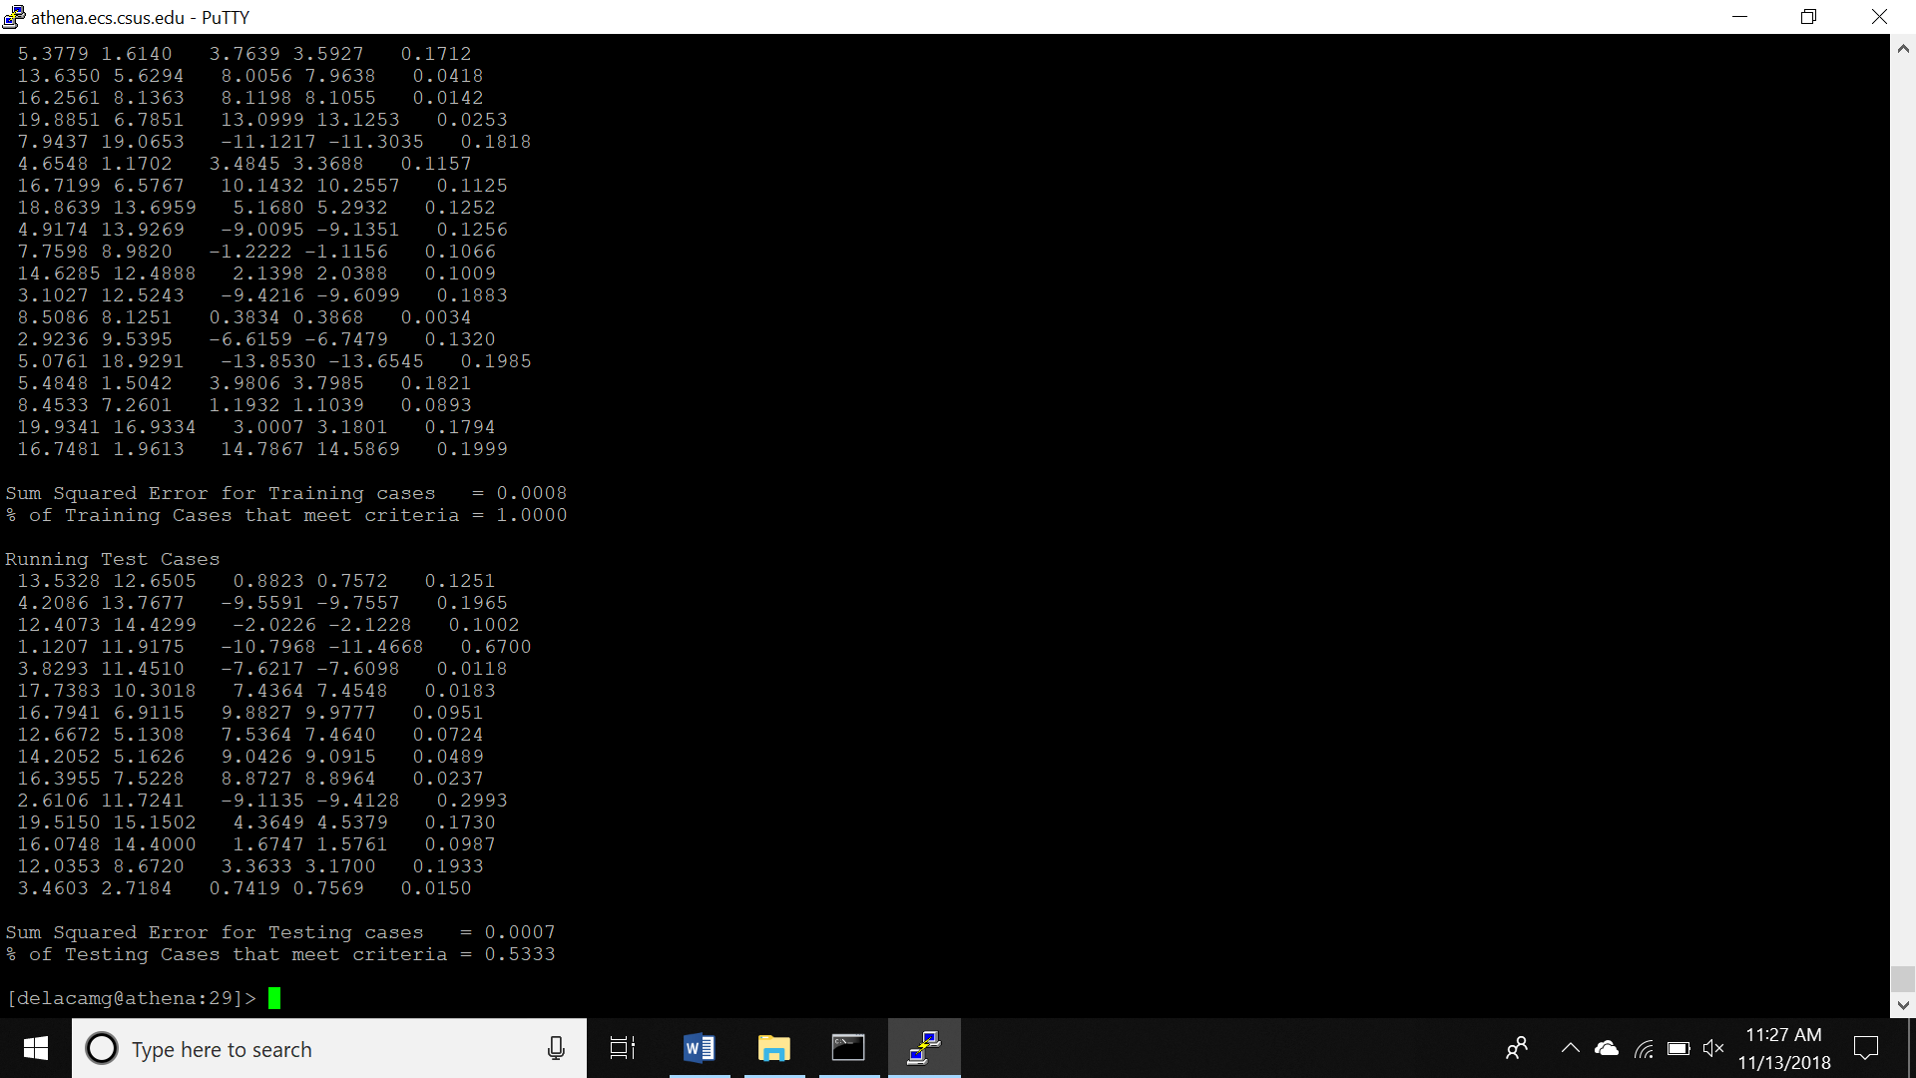

**Analysis 2a:**

* The Network was able to learn the training set with 100% of cases meeting criteria and with a sum squared error of 0.0008.
* The training took about 7.5 seconds to run 1000000 iterations.
* How well does it generalize? It generalized to 53.3%, which is an improvement over running all three at the same time.
* I think that it learned the data well it was able to meet criteria 53.3% of the time.

**Best case results for average:**

**Results 2b:**

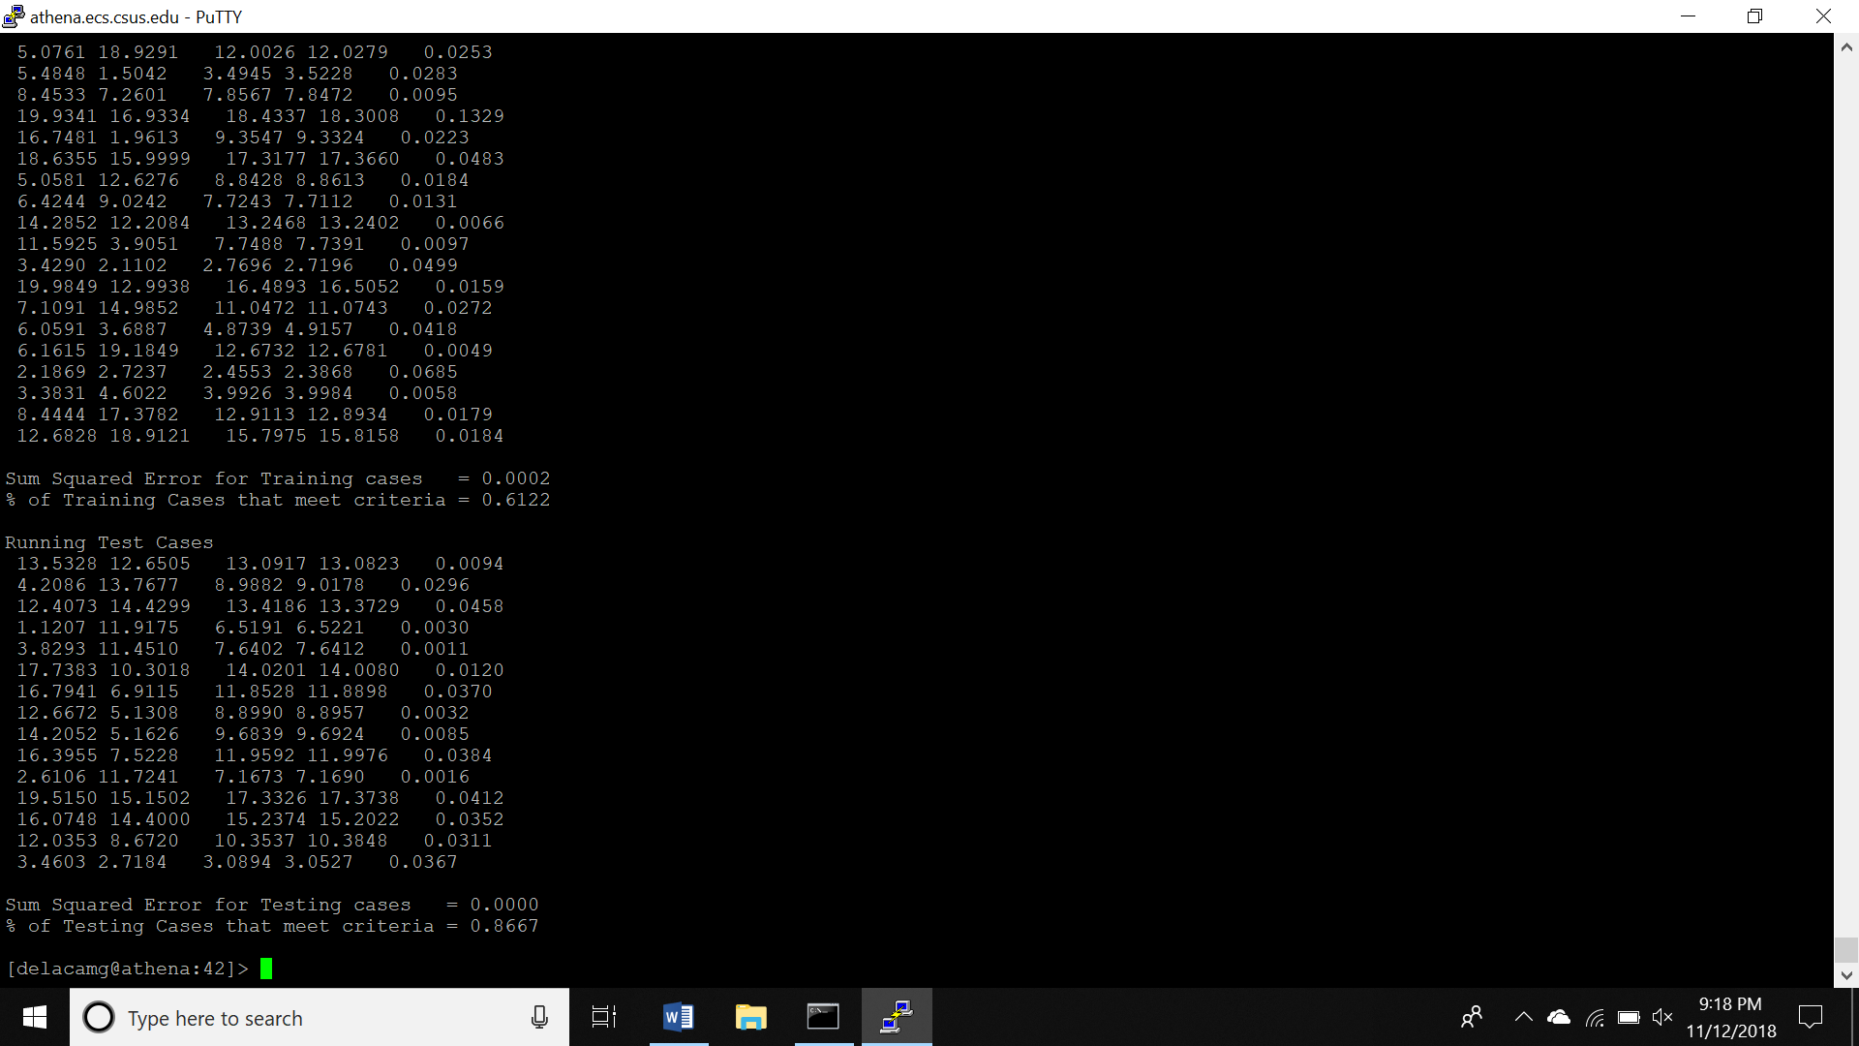

**Analysis 2b:**

* It terminated its learning after 1,000,000 iterations but in the time, it did run it learned the set to a precision of .62.
* The training took 8.22 seconds to complete.
* It generalizes very well with a precision of .87.
* It learned the problem well as it was able to generalize with a higher precision after training.

**Best case results for minimum:**

**Results 2c:**

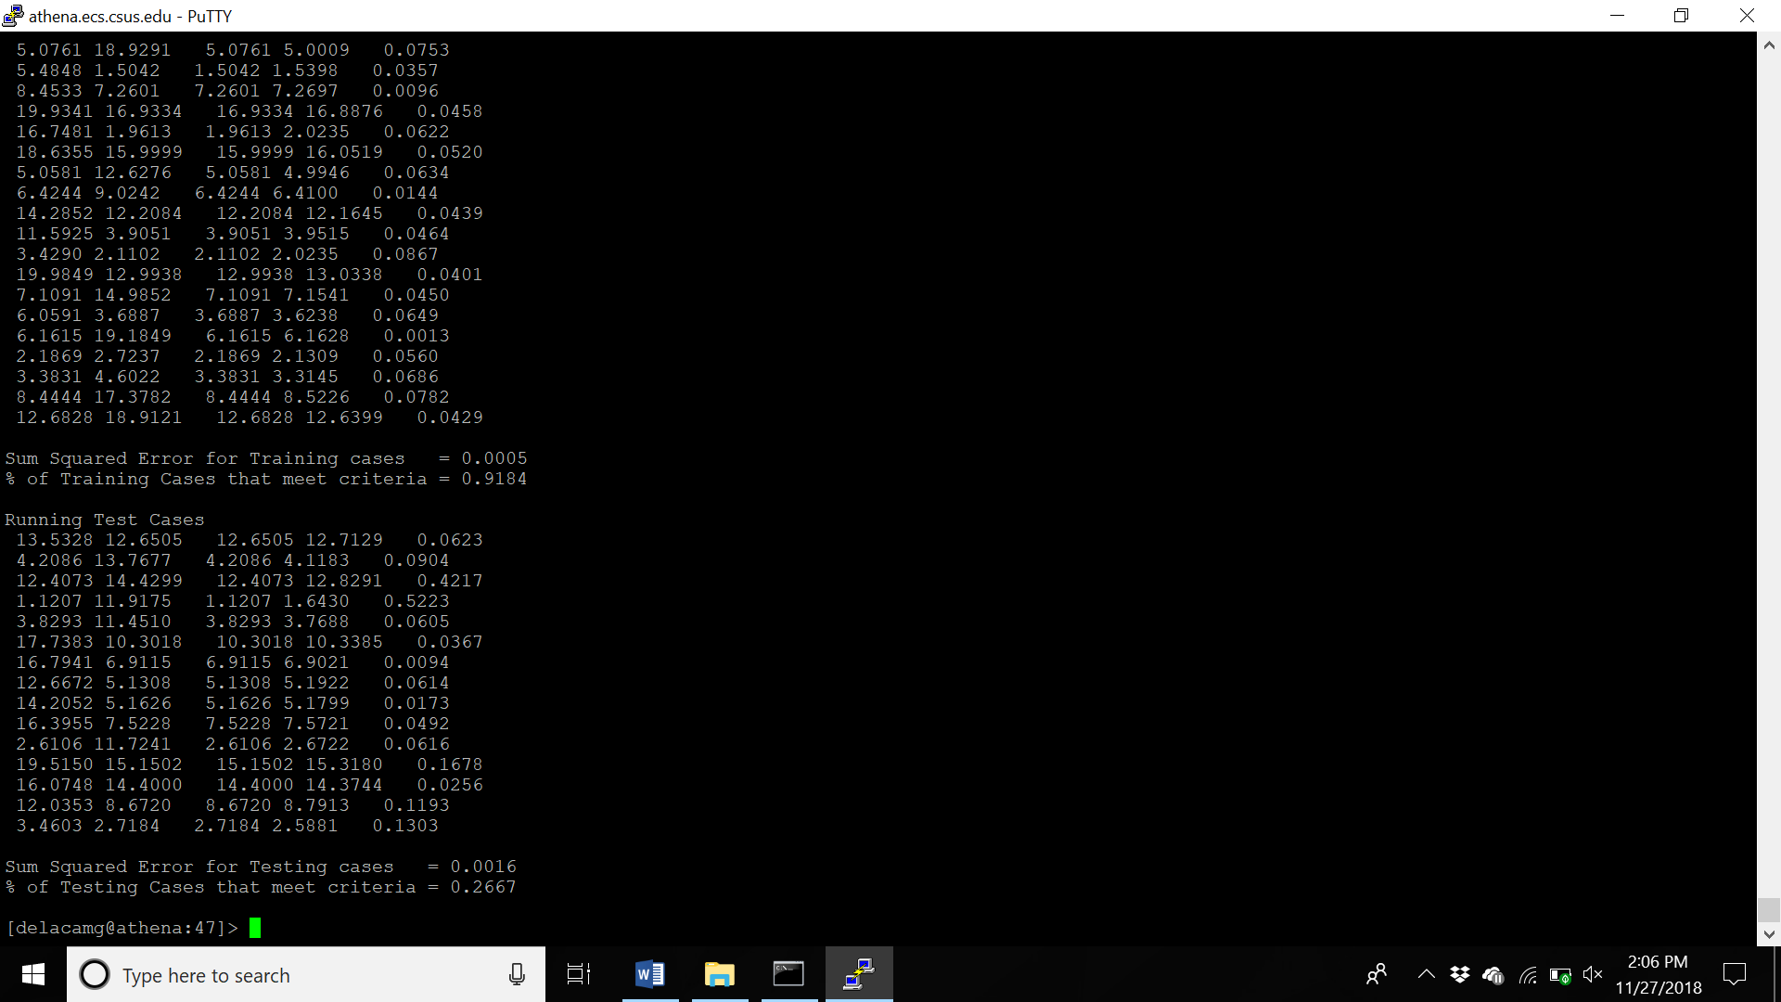

**Analysis 2c:**

* The Network timed out learning the training set 1,000,000 iterations in but during this time it learned the data to a precision of .92
* The training took 5.55 seconds to complete.
* The Network did not generalize well and was only produced a precision of .27.
* In respect to the learning precision the network did not learn the problem as well as it could have.

**Part3:**

**Image classification problem:**

The image classification problem we decided on was a dog verse a penguin. We thought that the subject of the penguin specifically would be easier to learn because of it distinct color pattern and relative consistent size. The dogs we had assumed might be harder to learn with so much variation of color, pattern, size and dimensions. Some examples of the images used are:

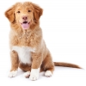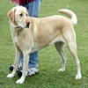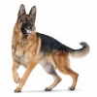

**Training data and testing data set development:**

To acquire the data set from both testing and training, we pulled images from Google (sources below that correspond to the numbers in the image files). We used <http://www.resizemypicture.com> to resize them all to 100 x 100 size. Image were chosen with a good degree of variation and of the total 40 of each, 5 were selected for testing.

**CNN architecture:**

The CNN architecture that worked best was when we added image augmentation with up to a 45-degree angle and we added additional convolutional layers in the network before each max pool layer. We did this because the image augmentation was a good way to increase our data set without having to pull in new images. In addition, during our research we found that adding conv layers tends to be one of the best sources of increasing precision and training accuracy.

**Results:**

The results for the base case (code the Professor Gordon provided) was able to predict 7/10 of the images correctly. With the modified code with image augmentation and additional convolutional layers, we were able to increase this to 8/10. It should be noted that to run the better script with image augmentation that it took 45 minutes vs 15 minutes for the base script. In graphs located below it can be observed that the accuracy was increasing with time. In other words the Network was learning more about the problem as it passed through the layers.

**Here are some of the screenshots of our results:**

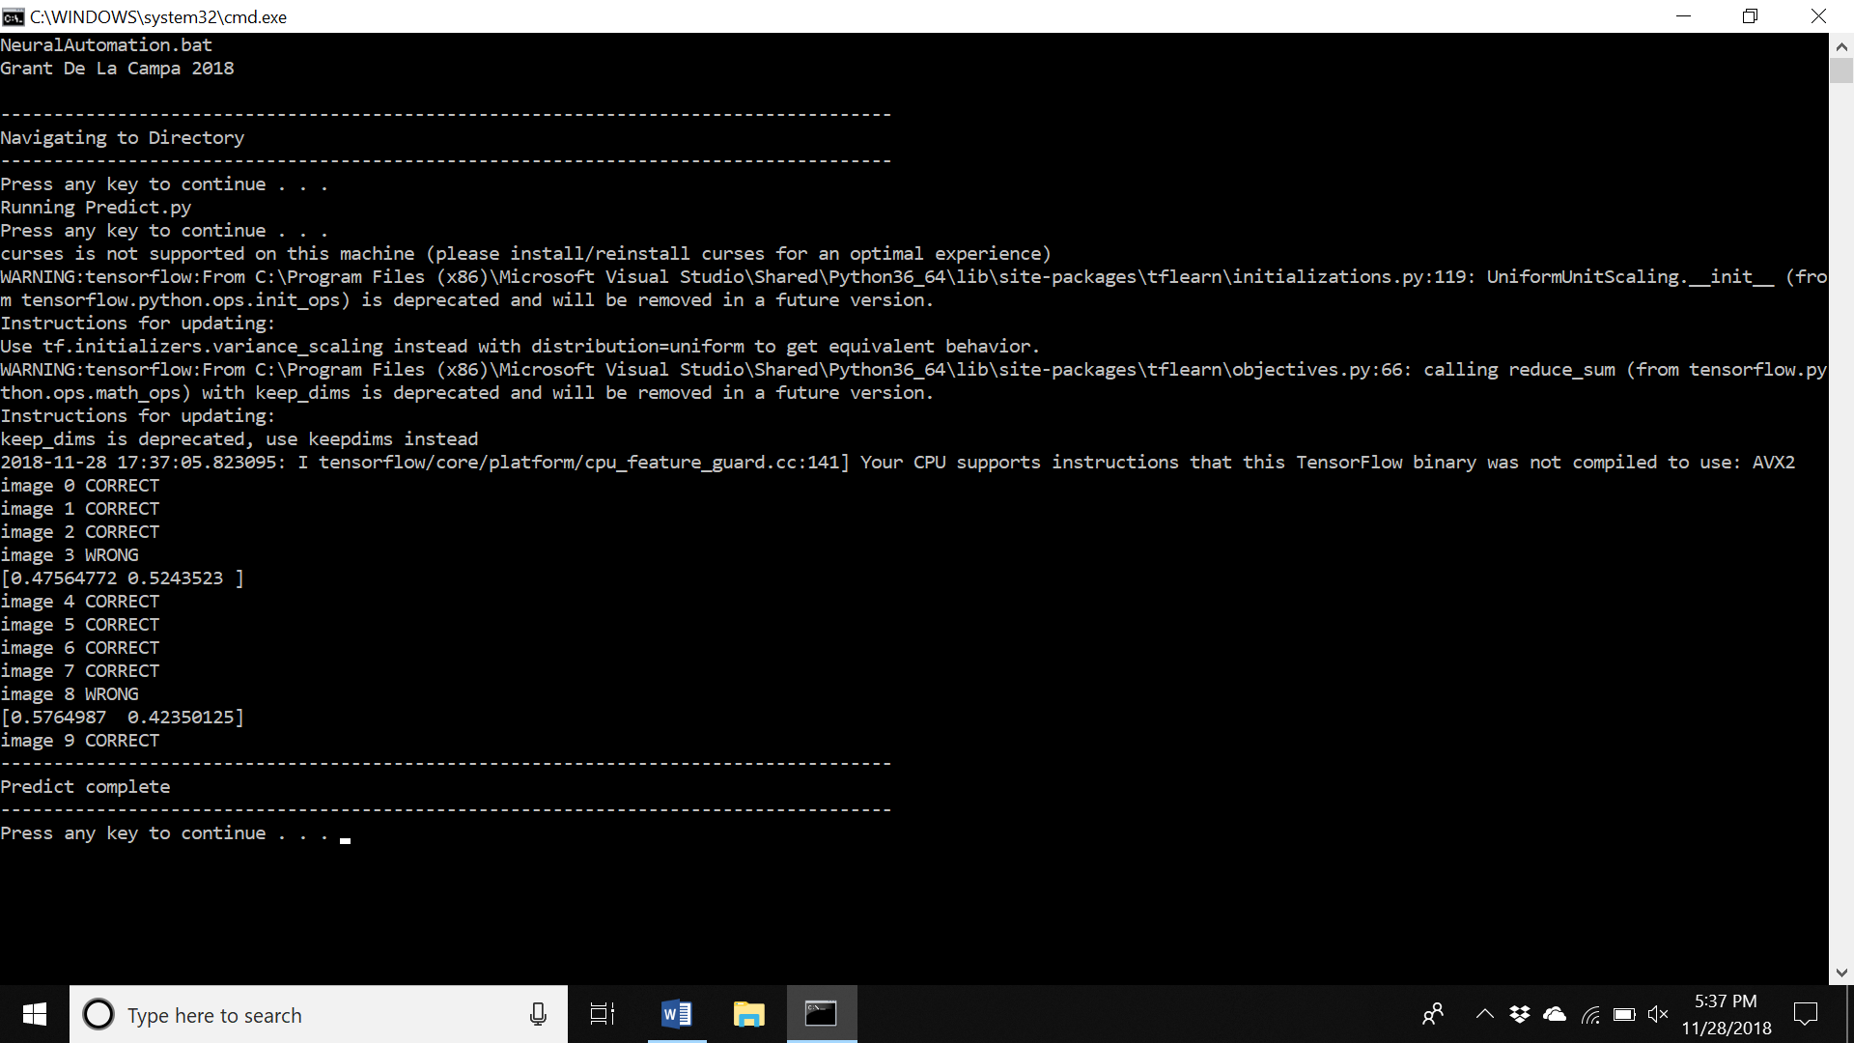

Figure 1:Neural Network with image augmentation and additional conv layer results

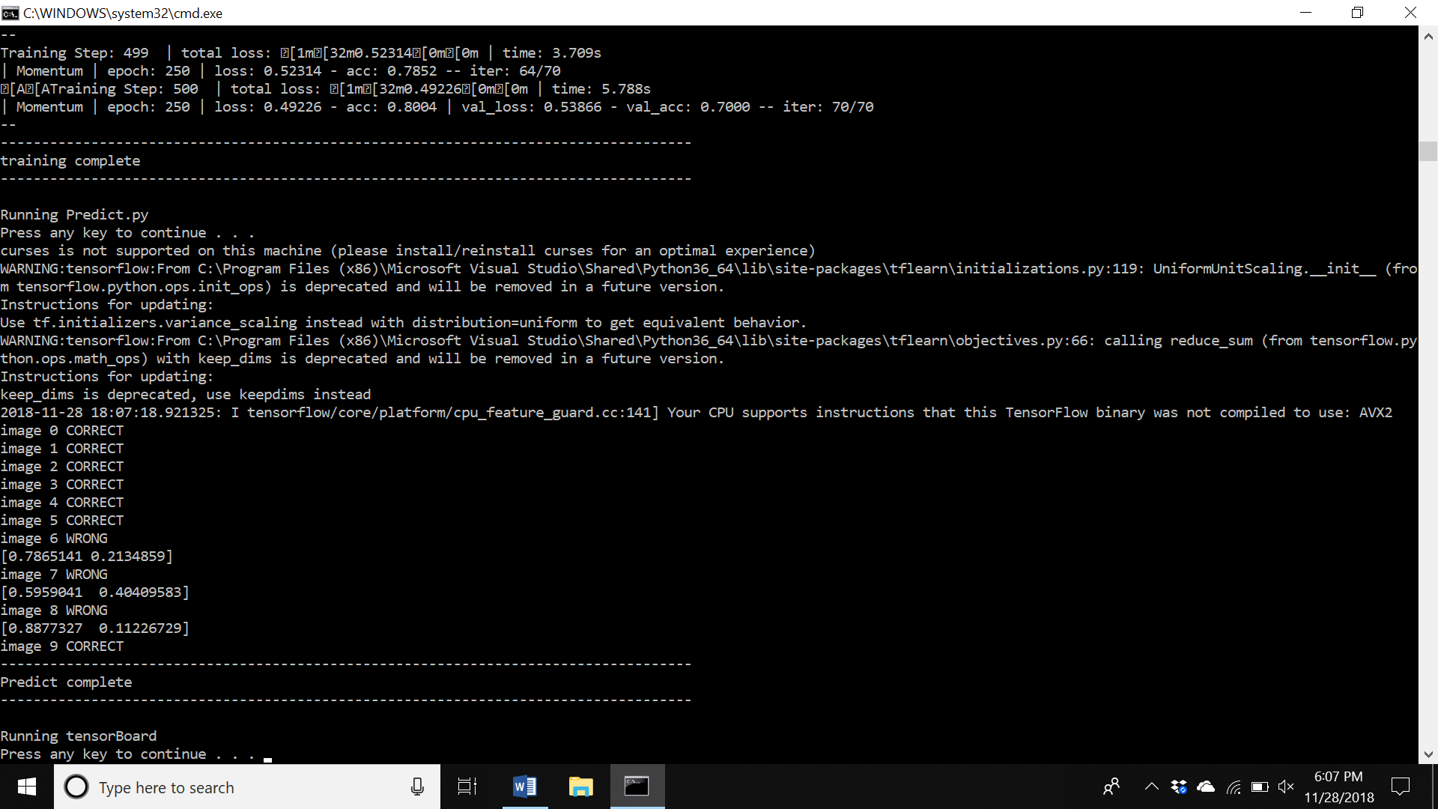

Figure 2:Neural Network base case

TENSOR GRAPH:

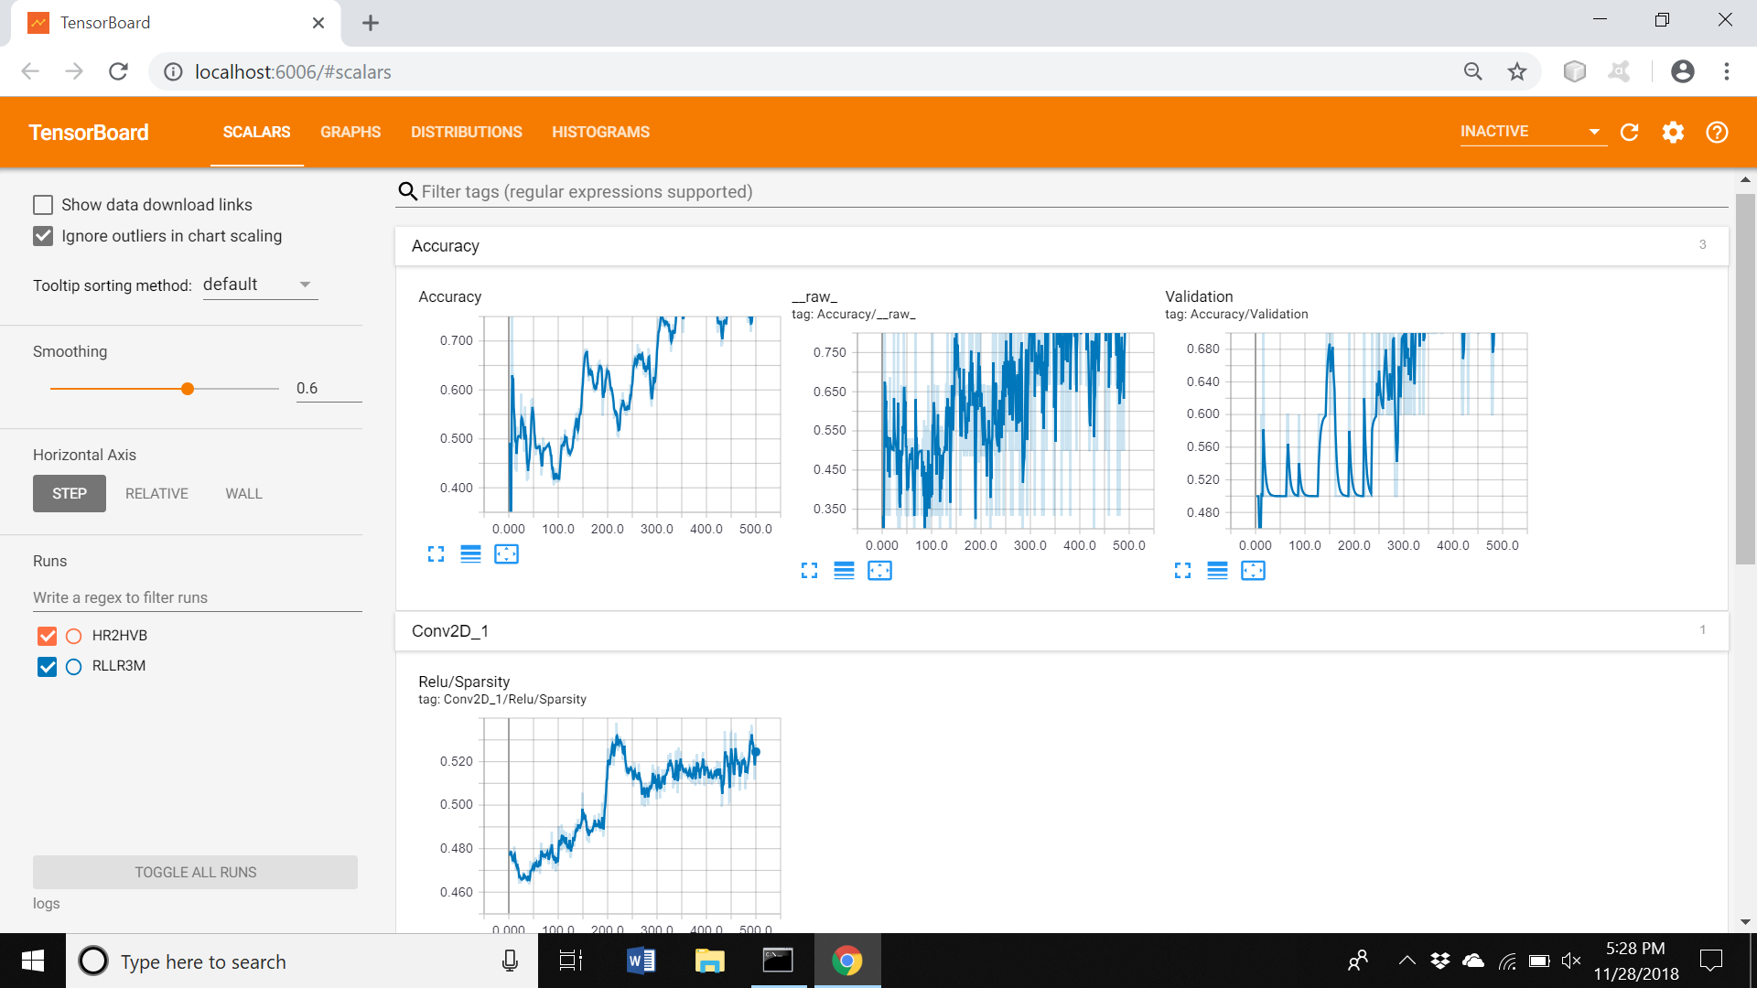

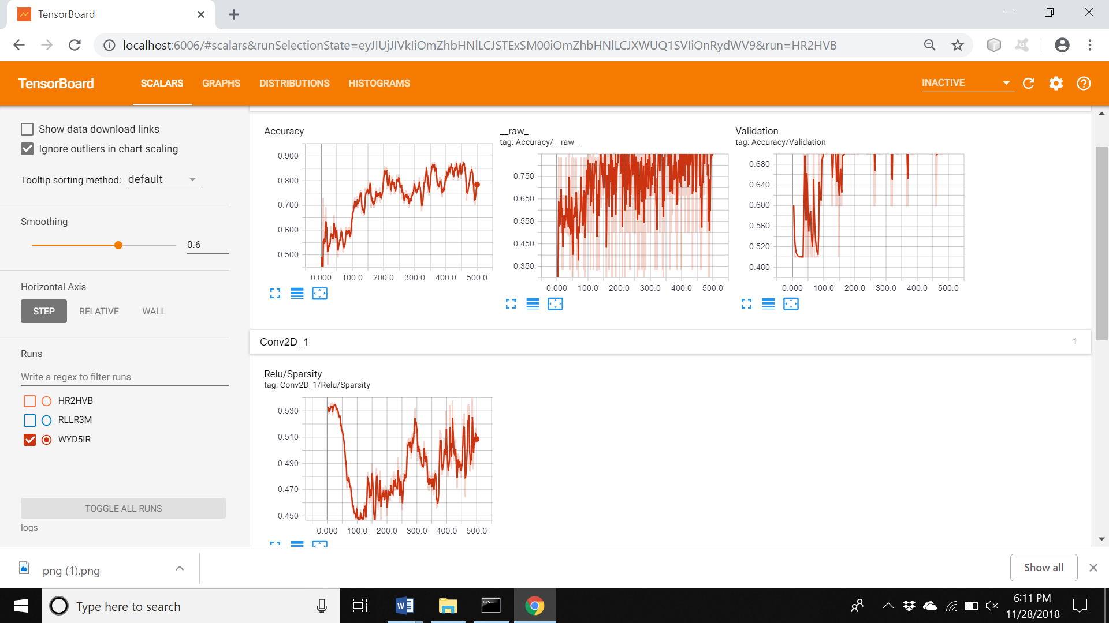

Figure 3: Neural Network with Augmentation scalars